English and Native American Masculinity in Jamestown

Grade: 9-12 and Undergraduates

Subjects: United States History, Virginia History, and World History

Time: 60-90 mins

Class Size: 2-30

Skills:
Students Will: | SOLs
VUS.1 The student will demonstrate skills for historical thinking, geographical analysis,  economic decision making, and responsible citizenship by:  a) synthesizing evidence from artifacts and primary and secondary sources to  obtain information about events in Virginia and United States history  c) interpreting charts, graphs, and pictures to determine characteristics of  people, places, or events in Virginia and United States history  f) explaining how indirect cause-and-effect relationships impact people, places,  and events in Virginia and United States history  g) analyzing multiple connections across time and place  VUS.2 The student will apply social science skills to understand the impact of the Age of  Exploration by:  a) describing the characteristics of early exploration and evaluating the impact  of European settlement in the Americas.  b) analyzing the cultural interactions among American Indians, Europeans, and  Africans.  VUS.3 The student will apply social science skills to understand early European  colonization by:  b) analyzing how social and political factors impacted the culture of the  Colonies.  WHII.1 The student will improve skills in historical research and geographical analysis by:  a) identifying, analyzing, and interpreting primary and secondary sources to make generalizations about events and life in world history since 1500 A.D  WHII.2 The student will demonstrate an understanding of the political, cultural, geographic, and economic conditions in the world about 1500 A.D. (C.E.) by:  b) describing artistic, literary, and intellectual ideas of the Renaissance | -VUS.1  -VUS.2  -VUS.3  -WHII.1  -WHII.2

Essential Question: How does work and leadership determine how we create gender normalities? How did Native men and women challenge English patriarchal culture?

Background:
As the English sought beyond their own borders to colonize other countries for financial gain, they brought their own values and social ideologies along with them. With its foundation in the works of a Christian humanist, Desiderius Erasmus, they believed that Christian societies should be structured with patriarchal authority. Patriarchy as we know it today means the systematic oppression of women by men. However, the ideology of patriarchy that the 17th century English practiced looked a bit different. The patriarchal “Great Chain of Being” meant that the father was the head of the household, but he was subservient to the King. The subordination of the wife and child or the citizen served as the foundation of patriarchal power. A man also relied on work and money to show his manhood to his peers, making industriousness, which was typically shown through physical labor, such as farming, a matter of image as well as survival. During the late 1500s, the English began to bring these ideas across the ocean.
The English colonizers were shocked when they interacted with the Native Powhatan people in the Chesapeake when they settled what is now Virginia in 1607. The social structure of their communities varied and did not rely strictly on patriarchal control or hierarchy. There was little difference between the werowance (commander) and his followers. While there was a hierarchy of leaders, their immediate council, and commoners, it was not material goods that separated them. Even the paramount werowance of the Powhatans, Wahunsenecawh, performed menial tasks such as making moccasins. In his tribe, women performed much of the labor, such as planting and harvesting. Some women even became Chiefs and leaders in their communities. This society structure appeared odd and even evil in the eyes of the English.
As these two groups began to mingle, English gender, especially masculinity, was challenged by the ideals of Native people. This lesson will help students understand how the life styles and culture of these two societies defined gender and masculinity
(For further background, refer to Chapter two of the American YAWP, chapter one of Pocahontas Powhatan Opechancanough: Three Indian Lives Changed by Jamestown, and chapter one of Good Wives, Nasty Wenches, and Anxious Patriarchs : Gender, Race, and Power in Colonial Virginia.)

Procedure:
- Open the lesson by showing the two pictures to the class. Have the students discuss them and provide descriptions to each one.
- Provide a lecture on the background provided above (Use the American YAWP for more information if needed).
- Have the students break into groups or convene as a class. Assign each group one or more documents and question sheets. Each group should read either one of the documents or both.
- Have each group present their findings to the class or go over each document as a class and discuss their findings.
- To wrap up and evaluate what the students have learned, have them look at the pictures from the beginning of the lesson. Have them compare the two images of an English man and a Native American man again. With a new understanding of English and Native gender roles, have the students come up with new descriptions based on their new knowledge.

References and Materials:

- Brown, Kathleen M, and Omohundro Institute of Early American History & Culture. 1996. Good Wives, Nasty Wenches, and Anxious Patriarchs : Gender, Race, and Power in Colonial Virginia. Heinonline Legal Classics Library. Chapel Hill: Published for the Omohundro Institute of Early American History and Culture, Williamsburg, Virginia, by the University of North Carolina Press.

- Rountree, Helen C. 2005. Pocahontas Powhatan Opechancanough : Three Indian Lives Changed by Jamestown. Charlottesville: University of Virginia Press.

- Smith, John. 1907. The Generall Historie of Virginia, New England & the Summer Isles : Together with the True Travels, Adventures and Observations ; and, a Sea Grammar. Travels of Captaine John Smith. Glasgow: J. MacLehose and Sons.

- American YAWP Online Textbook

College (undergraduate) adaptation:

Assign the first chapter of Good Wives, Nasty Wenches, and Anxious Patriarchs : Gender, Race, and Power in Colonial Virginia and the first chapter of Pocahontas Powhatan Opechancanough : Three Indian Lives Changed by Jamestown. You may also have them read the primary documents before class as well. Have the students discuss these chapters alongside the primary sources.

Sources (on separate pages that can be used as handouts):
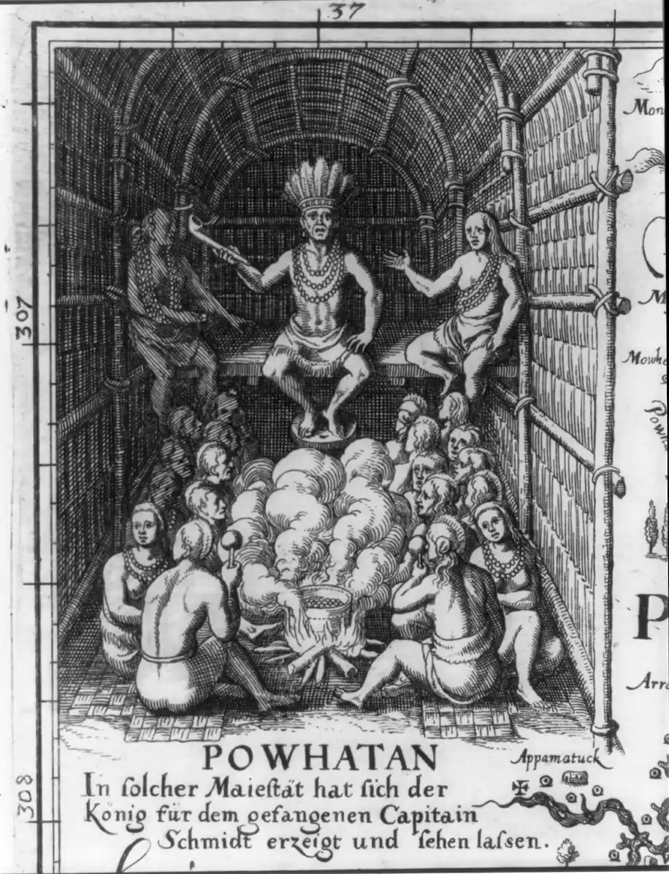
Detail of a map of Virginia from the early 1600s shows Powhatan, who was known as the “chief of chiefs,” wearing a crown of feathers at the height of his power. (Library of Congress)

​​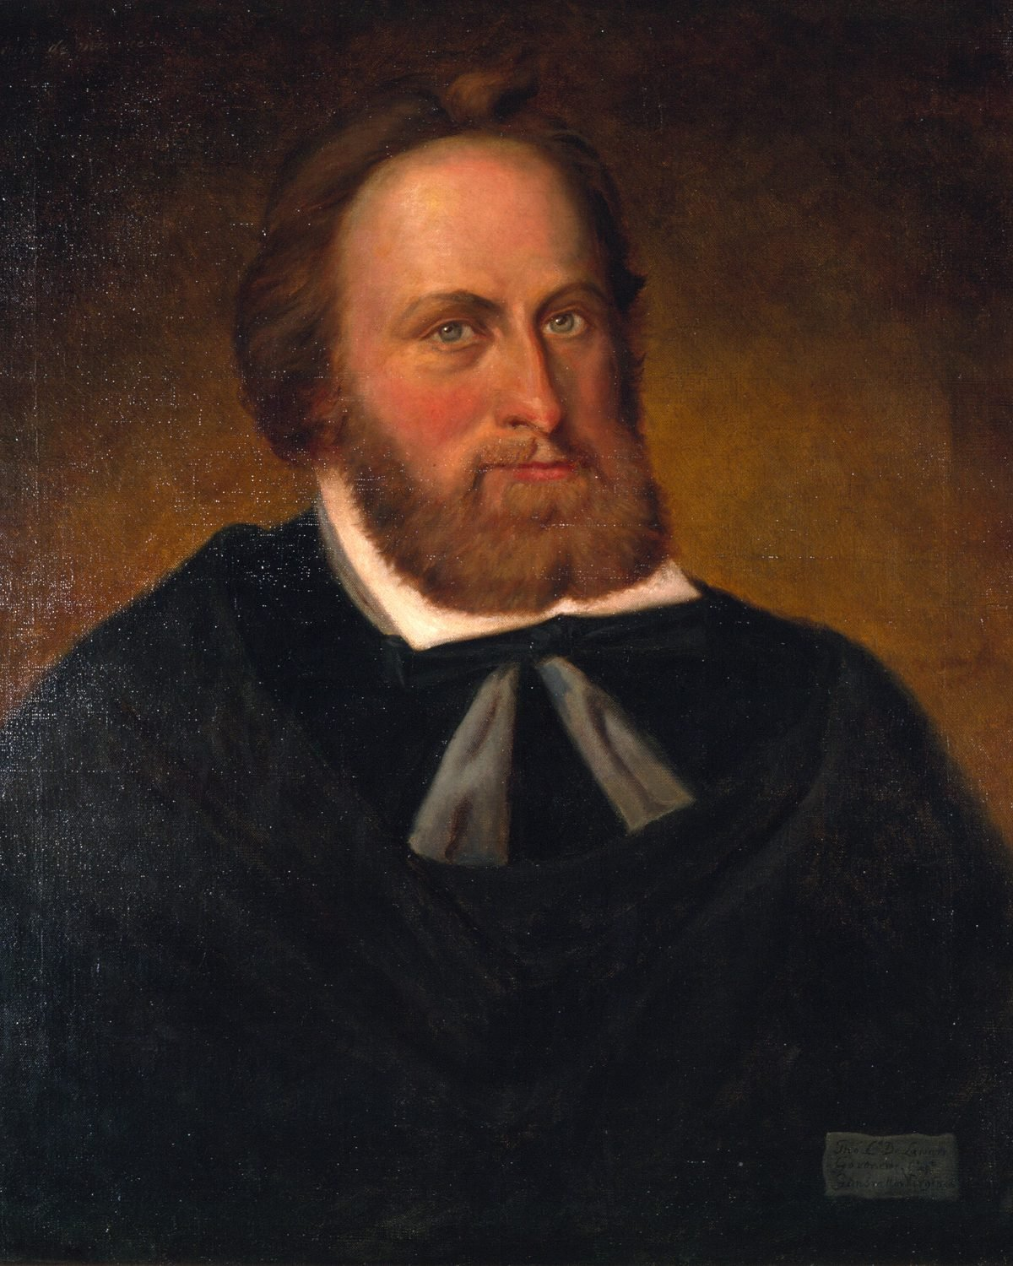
Thomas West, Lord De La Warre, William Ludwell Sheppard, Oil on canvas, 1877, Library of Virginia

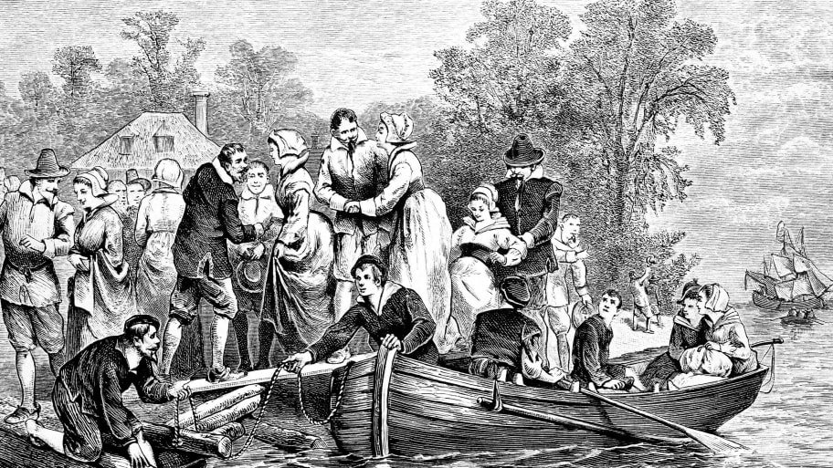

Library of Congress/AP

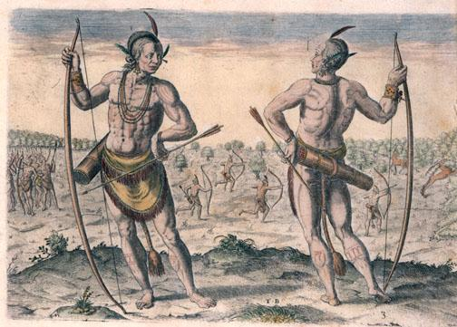
A Weroan or Great Lord of Virginia, de Bry engraving
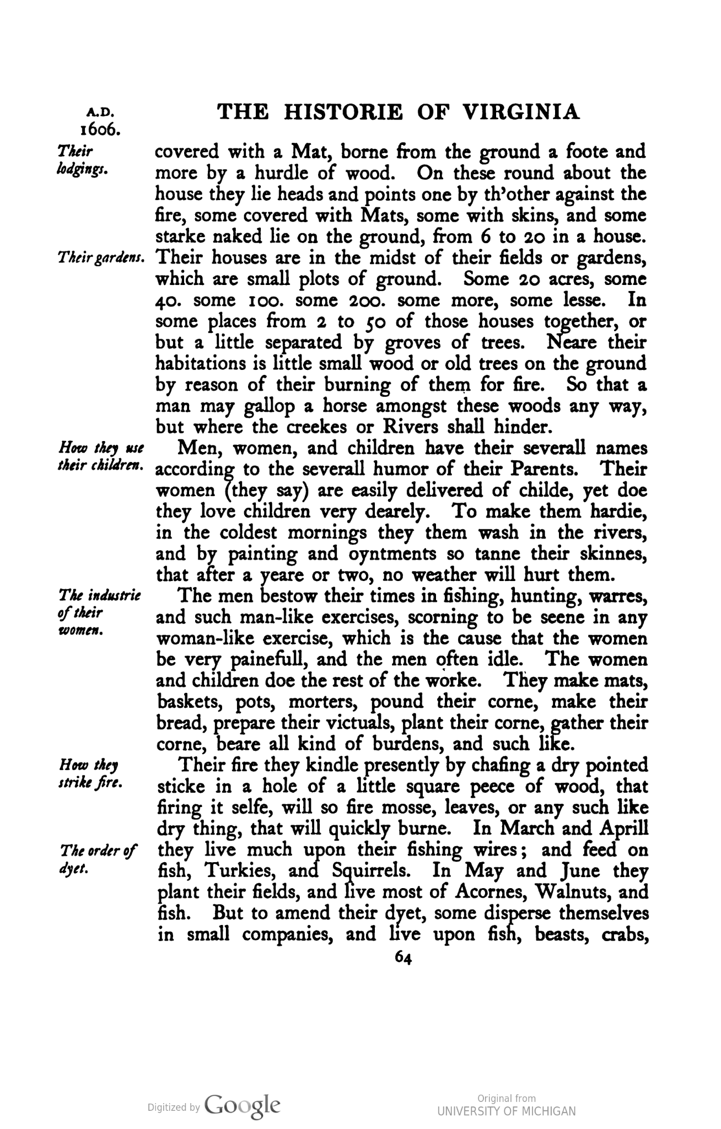
Account of the Powhatan tribe by John Smith- 1606.
“The men bestow their times in fishing, hunting, warres, and such man-like exercises, scorning to be seene in any woman-like exercise, which is the cause that the women be very painful, and the men often idle. The women and children doe the rest of the worke. They make mats, baskets, pots, morters, pound their corne, make their bread, prepare their victuals, plant their corne, gather their corne, beare all kind of burdens, and such like.”

Q&A Short Answer-

- What kind of labor do the Powhatan men perform? What labor do the women and children perform?

- Why would John Smith think the Native men were idle or lazy?

- How is this division of labor different from how the English would divide labor? How would this influence how the English acted towards them?
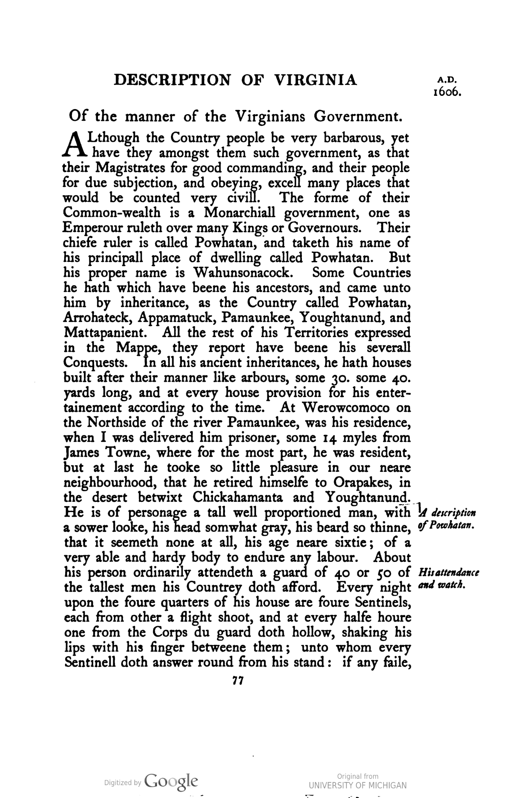
Account of John Smith Meeting Powhatan- 1606
“He is of personage a tall well proportioned man, with a sower looke, his head somwhat gray, his bread so thinne, that it seemeth none at all, his age near sixtie; of a very able and hardy body to endure any labour. About his person ordinarily attendeth a guard of 40 or 50 of the tallest men his Countrey doth afford.”

Q&A Short Answer-

- How does Powhatan’s appearance assert his status as a leader?

- What can you infer about the purpose and duties of his guards?

- How does John Smith’s account of Powhatan reflect his English upbringing?

For The Colony in Virginea Britannia. Lawes Divine, Morall and Martiall, &c. Alget qui non Ardet. Res nostrae subinde non sunt, quales quis optaret, sed quales esse possunt.
Printed at London for Walter Burre. 1612.

23. No man shall imbezzell, lose, or willingly breake, or fraudulently make away, either Spade, Shovell, Hatchet, Axe, Mattocke, or other toole or instrument uppon paine of whipping.

25. Every man shall have an especiall and due care, to keepe his house sweete and cleane, as also so much of the streete, as lieth before his door, and especially he shall so provide, and set his bedstead whereon he lieth, that it may stand three foote at least from the ground, as he will answere the contrarie at a martiall Court.

30. No common Souldier shall sell, or make away any of his apparell, which is delivered unto him by the Colonie, or out of the store, upon paine of whipping

32. What man or woman soever, shall rob any garden, publike or private, being set to weed the same, or wilfully pluck up therin any roote, herbe, or flower, to spoile and wast or steale the same, or robbe any vineyard, or gather up the grapes, or steale any eares of the corne growing, whether in the ground belonging to the same fort or towne where he dwelleth, or in any other, shall be punished with death.

38. No Souldier may speake or have any private conference with any of the salvages, without leave of his Captaine, nor his Captaine without leave of his chiefe Officer, upon paine of death.

47. Whosoever shall faine himself sick, upon the point of fight, or when any worke is to be done or slip away from the service of either, shall be punished by death.

Q&A Short Answer-

- Based on the laws, describe what kind of labor men in Jamestown were performing?

- What is the purpose of these laws? What are they reinforcing?

- What can you infer about the importance of a man’s uniform and tools?

- After reading the laws, how would they describe a masculine man?

